

**PES UNIVERSITY**

***(Established under Karnataka Act No. 16 of 2013)***

***100 ft Ring Road Campus, Bengaluru – 560 085, Karnataka, India***

*Project report on*

“Network Analysis and Synthesis (NAS) QUAC Simulation”

**Submitted by**

Mahanta Talakal (PES1UG22EC145)

Mayur S (PES1UG22EC158)

Manthan BT (PES1UG22EC907)

***For the partial fulfilment of the course NAS***

***(Network Analysis and Synthesis)***

**UE22EC242A**

Electronics and Communication Engineering

**Submitted to**

Dr. Anuradha M

Faculty of Engineering

(Program: B.tech)

**1.Star and delta transformation:**

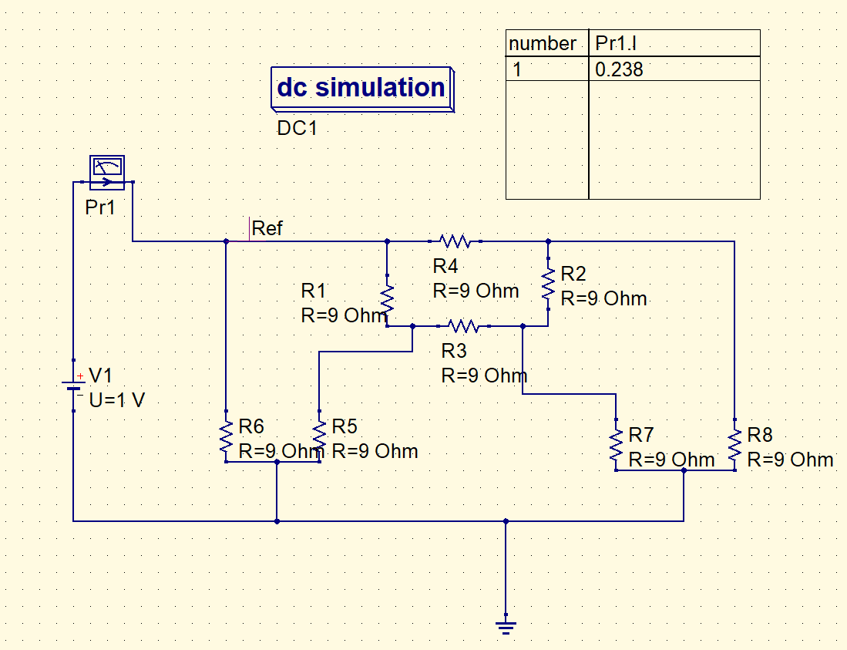 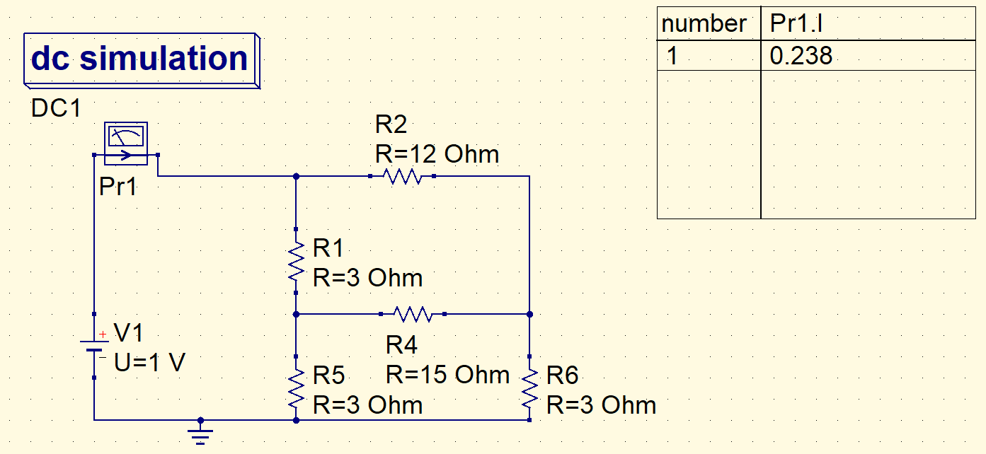 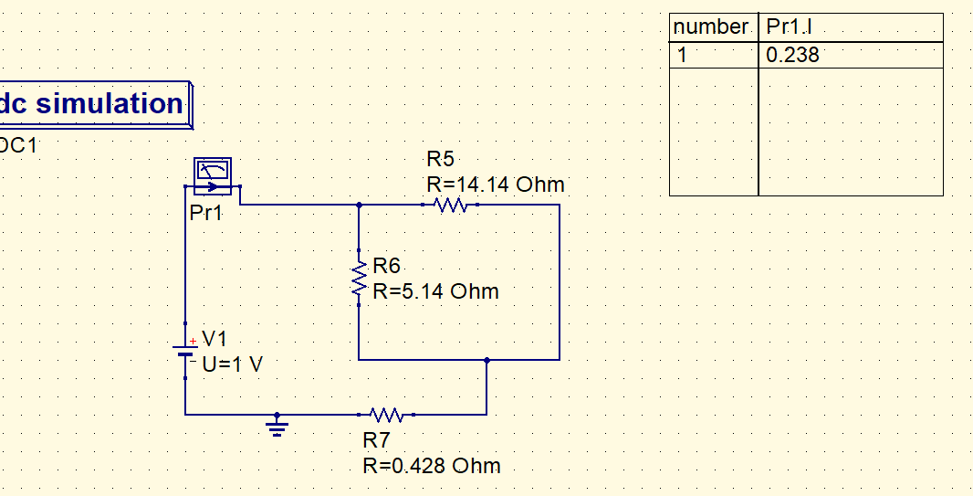 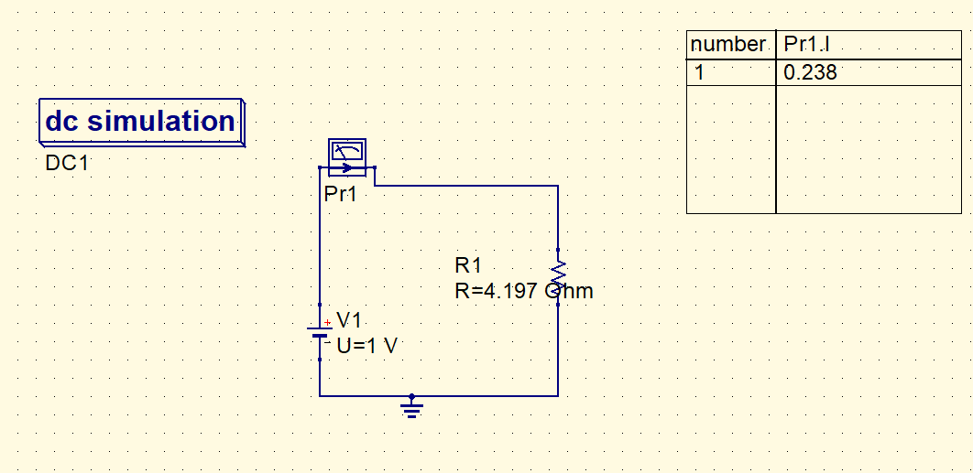

**2.Millmans theorem:**

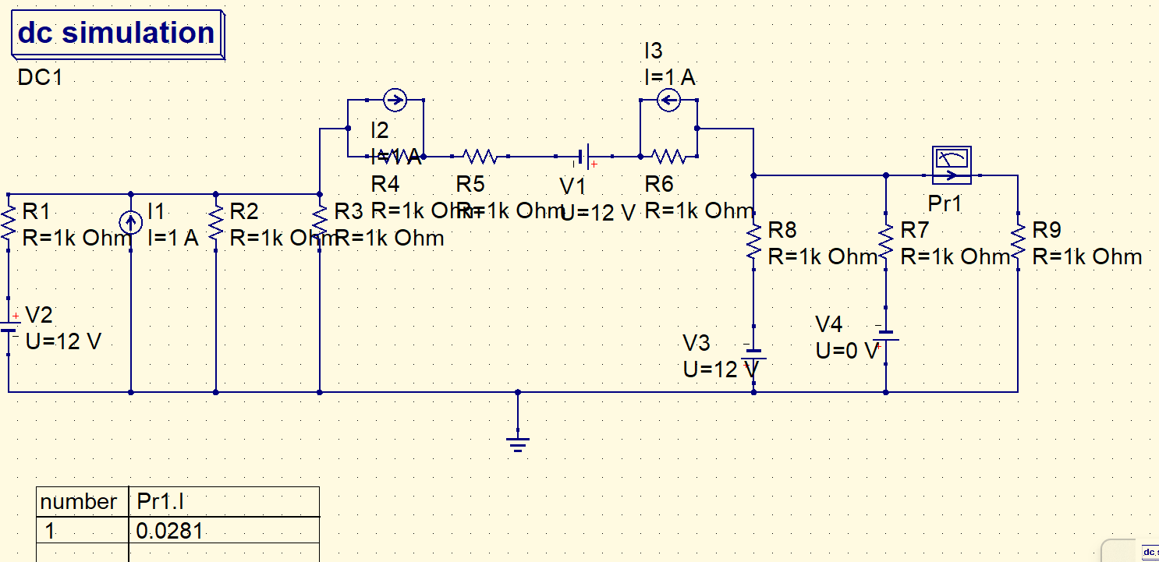 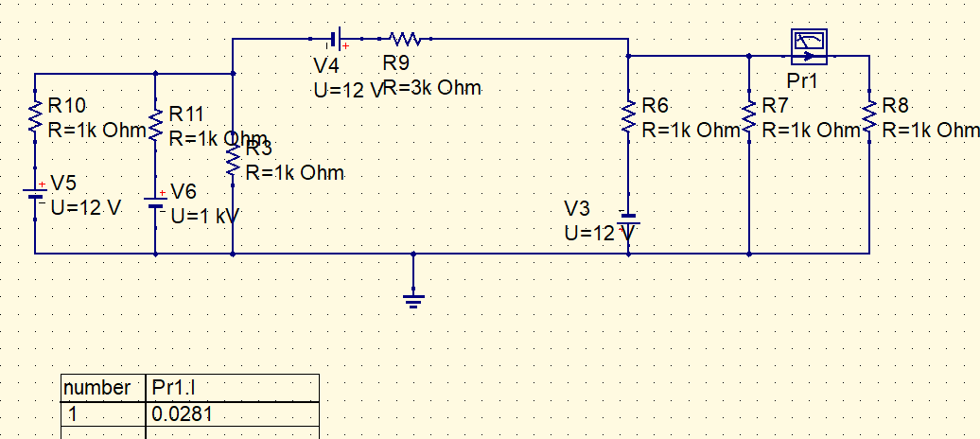

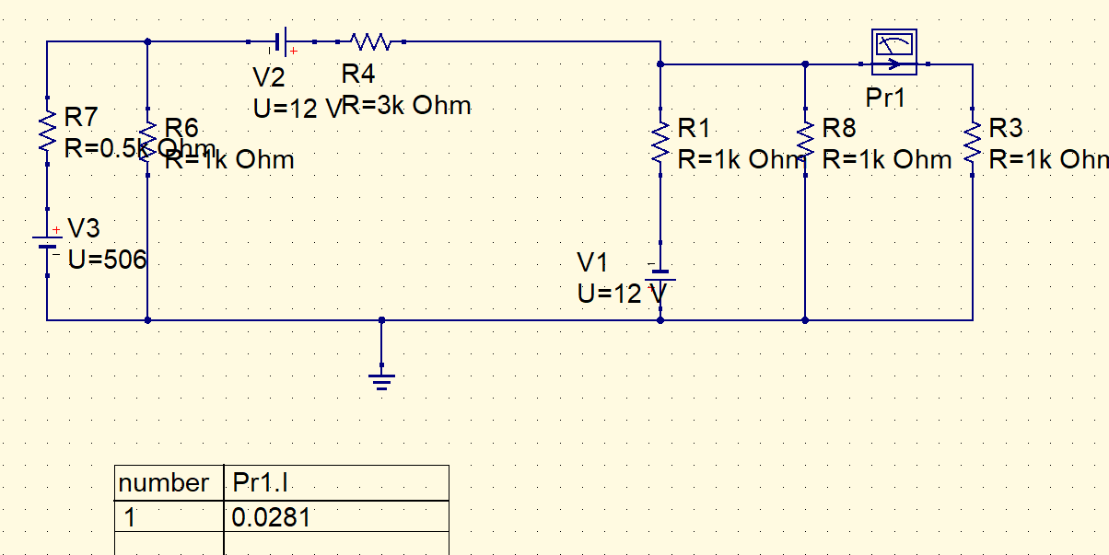

**3.FIRST ORDER TRANSIENT ANALYSIS:  
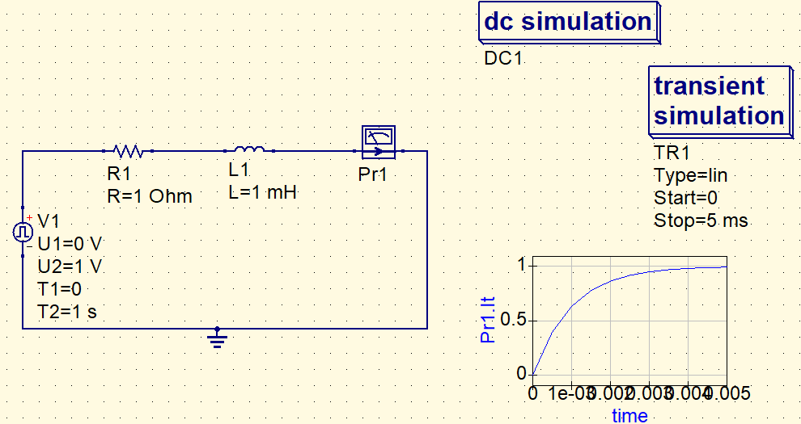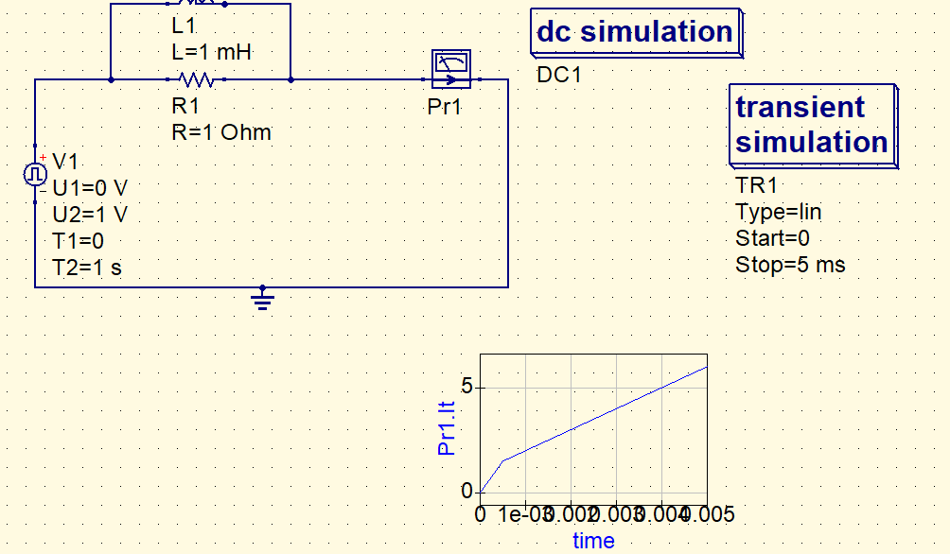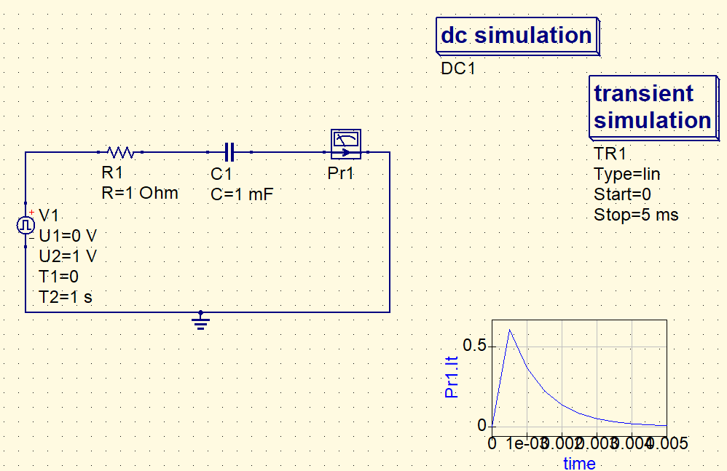 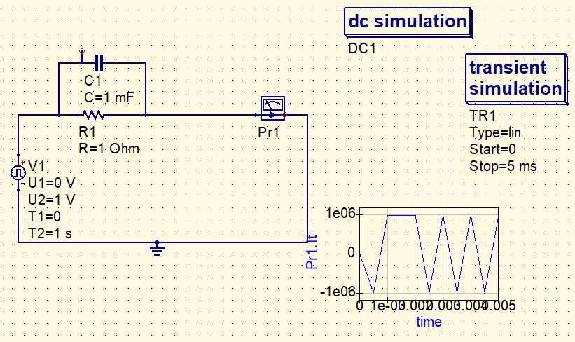**

**4.Superposition Theorem:**

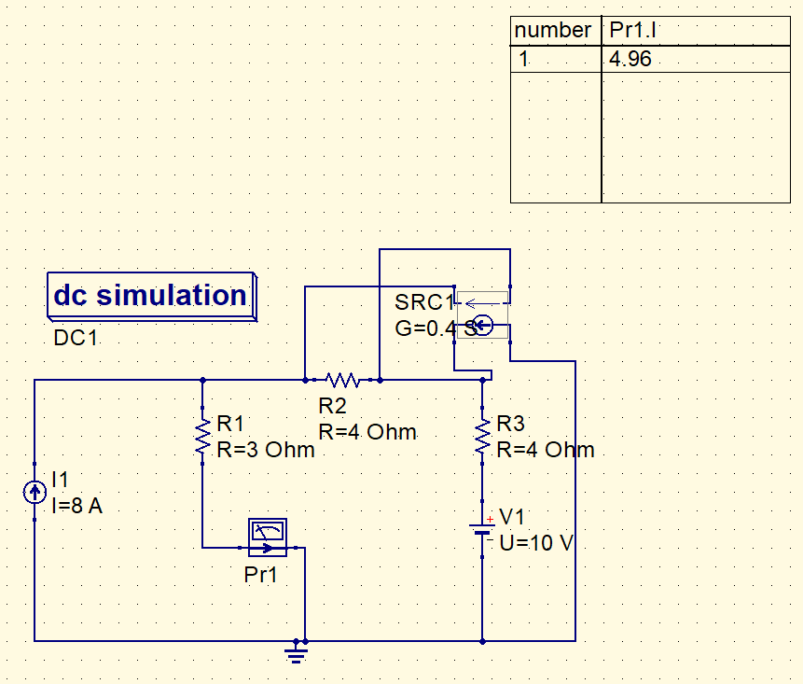 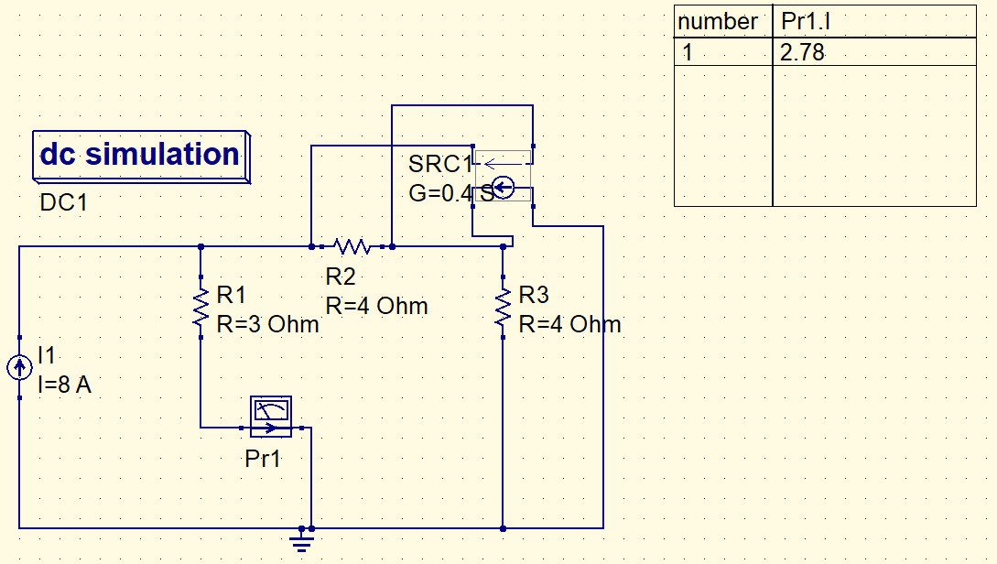

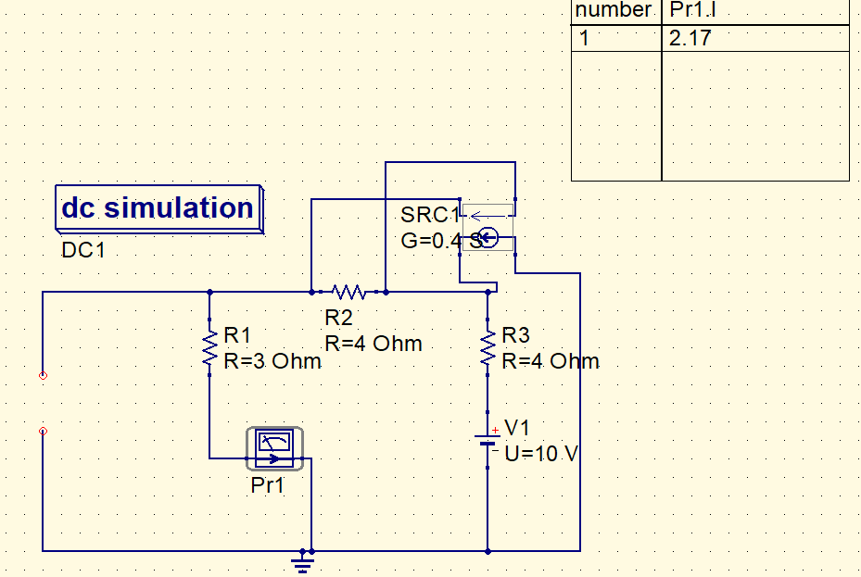

**5.Reciprocity theorem:**

